NOTICE OF CONFIDENTIAL INFORMATION WITHIN COURT FILING

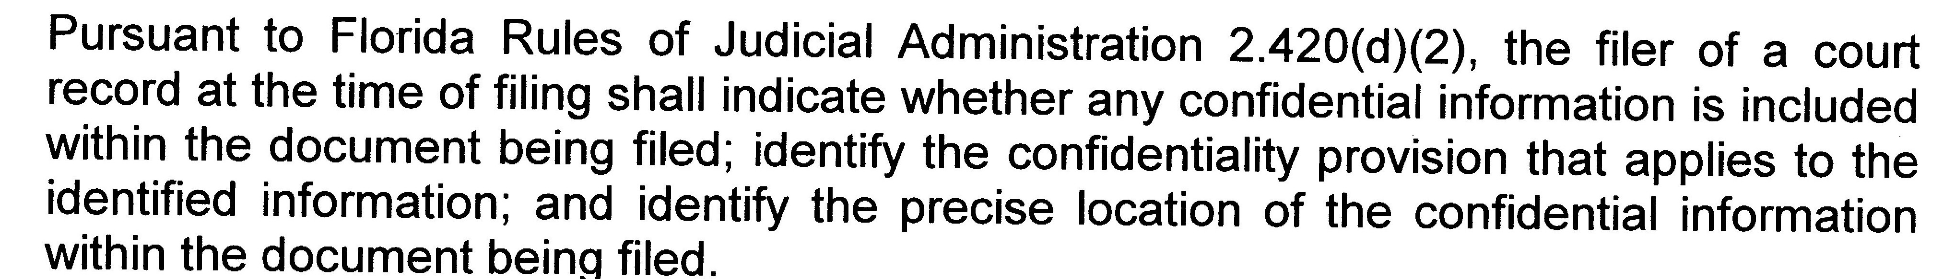

Title/Type of Document(s): Exhibits for Motion for Final Trial

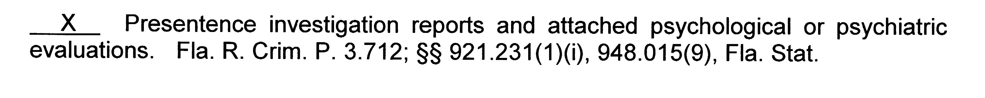

Respectfully submitted.

By:________/S/____________________________________
Signature of Father
Mario Jimenez, M.D.
Pro Se

CERTIFICATE OF SERVICE

I certify that a copy of this document was emailed to the person(s) listed below on February 9th, 2015.

Ana C. Morales, Esq., Anastasia Garcia
Attorney for Former Wife Guardian Ad Litem
Reyes & Arango Moore, P.L. agarcia821@aol.com
amorales@ramlawus.com,
receptionist@ramlawus.com,
yreyest@ramlawus.com

___________________/s/_________________________
Signature of Father
Mario Jimenez, M.D.
Pro Se

